|  |  |
| --- | --- |
| Web - 701  Student Id - 13491449 | Prapti Mane  Web 701 |

Table of Contents

Purpose of web frameworks 2

Common Framework Features 3

Features used in Website 4

Proposed Web Frameworks 5

Why Angular: 5

Why VueJs: 5

Register, Login, Administer Accounts 5

Angular 5

VueJs 7

Code Snippets 13

Comparing Frameworks – Registration and Login 13

Members Use the Website to register their products. 14

Angular 14

VueJs 16

Code Snippet 16

Comparison 18

Interactive Engaging Elements 19

Angular 19

VueJS 20

Comparison 21

Store and Retrieve Data from Server-Side Database 22

Angular 22

VueJS 24

Comparisons 28

Recommendation of a Framework 28

Bibliography 30

# Purpose of web frameworks

Web framework is a software framework which is created to support the development of dynamic websites, web applications and web services. The development of a dynamic website is made easy with the use of a web framework. It provides a basic pattern of the code which helps quicken the process of web development. Web frameworks help simplify the process of web development and keep it as modern as possible. Web frameworks automates the repetitive web development tasks. Web frameworks gives you a process for turning an idea into code. A framework is a basic conceptional structure. Most of the applications have a common set of functionalities such as handling session data validation etc, and web framework prevent a developer from re-writing the same code every time to create a web app. The purpose of frame works is to allow developers to build unique features for their web projects instead of rewriting the same code repeatedly. Each framework may provide you a wide range of web app functionalities, resulting in a less error-prone program. In a nutshell, a framework aids in the prototyping, design, and implementation phases of the app development lifecycle, as well as the continuing maintenance and enhancement of a web application. Frameworks are very helpful when it comes to online security. Coming up with your own security is costly and dangerous if you do not do it right. To make anything more resilient, a framework can incorporate security aspects into its functioning and combine bug-fixing efforts. A framework can be secure by default, at least in theory. Most applications/websites these days require login, signup, password rest, authorization, API’s, logging, database, sending emails, payment processing, deployment, input validation etc, if a beginner must implement all of this in their design without a framework, they would be lost, but with the help of a framework these tasks can be implemented easily and can be reused if possible.

There are two types of Frameworks Client side(frontend) and Server(Backend) side frameworks

Server side – These control the database, the logic of the application, payment methods, security of the website and the server configurations. Some of the common server side frameworks are, expressjs, ruby on rails, Laravel, Django etc

Client side – Everything that you see on the website in the UI is controlled using the client side frameworks. Some of the common client side frameworks are, vue.js, angular, react etc.

## Common Framework Features

Some of the common features in a web framework are:-

**Caching –** Web caching helps save documents while reducing bandwidth consumption., server load and perceived lag. A web caches stores copies of pages that travel through it and if certain requirements are met, the following request can be served from the cache. Some application frameworks have features for caching documents and skipping certain stages of page preparation such as database authentication. (Web)

**Security –** Most frameworks these days come with authentication and authorization, which helps with the login, register etc of a web application, this helps restrict access to users which don’t meet the defined criteria. Security in a system allows users to view pages based on their roles and has a web-based interface for establishing users and assigning them roles. (Web)

**Database access, mapping and configuration -** Many web frameworks provide a single API to a database backend, allowing web applications to interact with a range of databases with no code modifications and programmers to focus on higher-level concepts. (Web)

**URL Mapping -** The process through which a framework reads URLs is known as URL mapping or routing. Shorter, more "friendly URLs" can be used with a URL mapping system that employs pattern matching or rewriting to route and manage requests, boosting the site's simplicity and allowing for easier indexing by search engines.

**AJAX (“Asynchronous JavaScript and XML”) –** Is a technique which is used for creating web applications. The goal is to make web pages feel more responsive by exchanging little pieces of data with the server behind the scenes, rather than reloading the complete page every time the user demands a change. This is done to improve the interactivity, speed, and usability of a web page.

**Web Services -** Some frameworks include web service creation and provisioning features. These tools may be comparable to those found in the rest of the web application.

**HTML** **(or Hypertext Markup Language) -**  It is a computer language used to build websites.

**CSS (or Cascading Style Sheets)** – It is a language used for styling websites. HTML elements are represented using CSS on a web page. It helps with design, layout, screen sizes etc. It helps beautify a web page.

**Components –** Web Component-based custom components and widgets will function in all modern browsers and may be used with any JavaScript library or framework that works with HTML.

## Features used in Website

The features which are used in the project are URL Mapping, the URL routing is more user friendly. So, the users can easily tell what page they’re on instead of reading through some complicated routes. We have also used the security feature on the website, we have used JWT authorization to always keep the user accounts secure. We also have different login accounts of different users, e.g., the content visible to an admin user is restricted to an admin account, whereas the user account will only have access to the content we want visible for regular users. Hence the security on the website has been given priority. We have also used Database access, mapping, and configuration, we have used MongoDb to store our database. We also have the feature of web service on the website since we do have a server running on our computer, listening to port over a network, serving our web documents. (htt21). For the front end we have used components (Material components). These are interactive building blocks for creating a user interface. Angular has a proper documentation which explains well how to use these components on the website. Everything you see in the UI is made up of different components.

# Proposed Web Frameworks

The two frameworks we recommend for this project are Angular and VueJs.

## Why Angular:

Because it eliminates the need for extraneous code, Angular ensures that development is simple. It has an MVC architecture that eliminates the need to write getters and setters. Because directives are not part of the app code, they can be controlled by another team. Developers can expect less coding and lighter, faster apps in general.

## Why VueJs:

Vue.js is a JavaScript progressive framework for building web interfaces and one-page applications. Vue.js is utilized not only for online interfaces, but also for desktop and mobile app development utilizing the Electron framework.

# Register, Login, Administer Accounts

## Angular

Below is the screenshot of the Sign Up Page using Angular - <http://localhost:4200/signup>

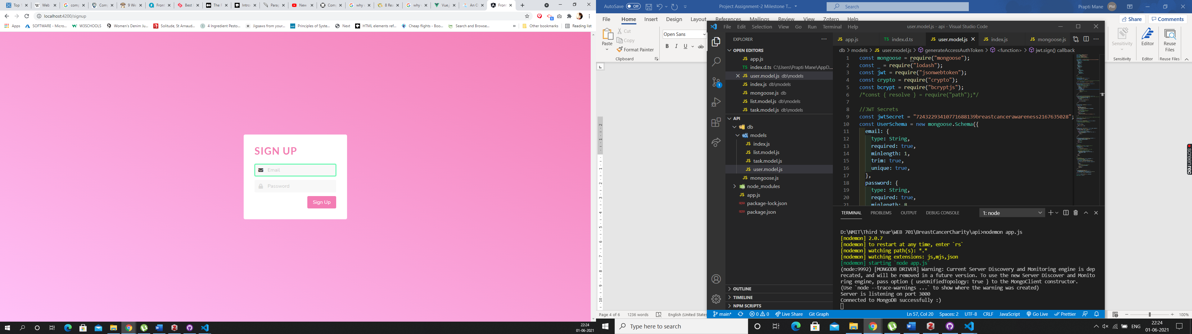

If you inspect the page after putting in your details and clicking the sign up button, you will see in the console that you get a “successfully signed up and logged in” message. Below is the screenshot showing that information

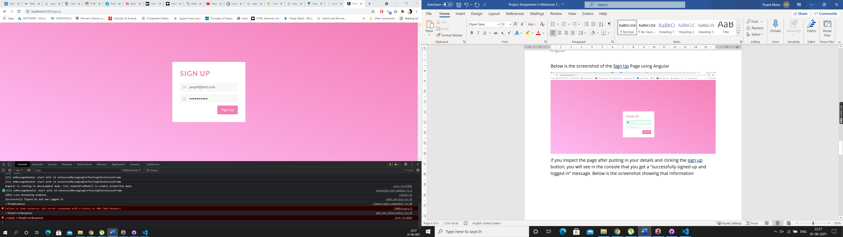

Below is the screenshot of the login page - <http://localhost:4200/login>

We logged in using – [prapti@test.com](mailto:prapti@test.com) password – helloworld

Once you inspect the page and check the console you should be able to see the “logged in” message with the status as 200 and true. Which means the user has successfully logged into the app.

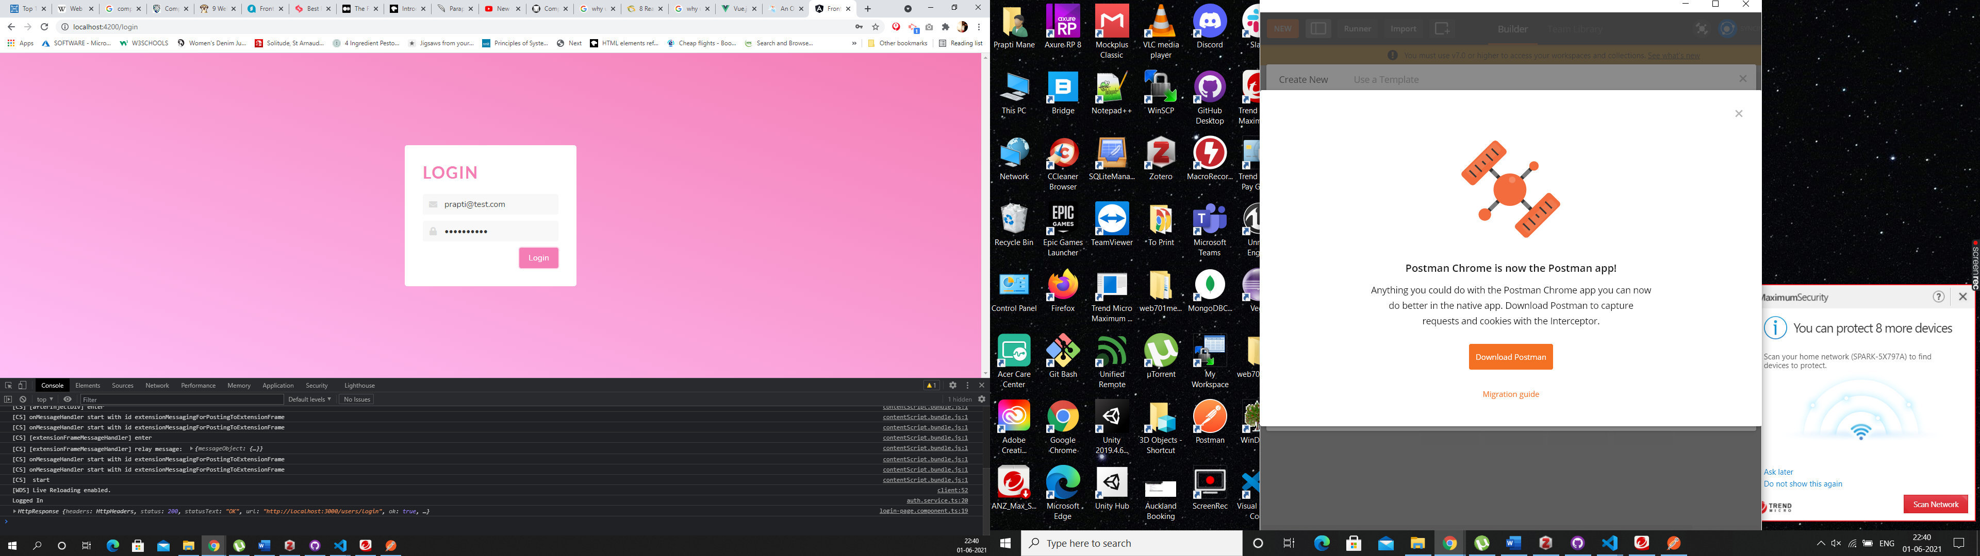

At this stage for Angular we do not have different login’s set up, but for the final product we will have different login and content for Admin, Moderator and User, we do have a working example of that in VueJs which we will show you next.

## VueJs

Below is the main screen which will consist of the public content of the website, which is general content, so any information about the charity etc and content that is not targeted towards certain users only will be on this page. This will be the Homepage of the website. We just have the skeleton of the website at this stage for demo purpose.

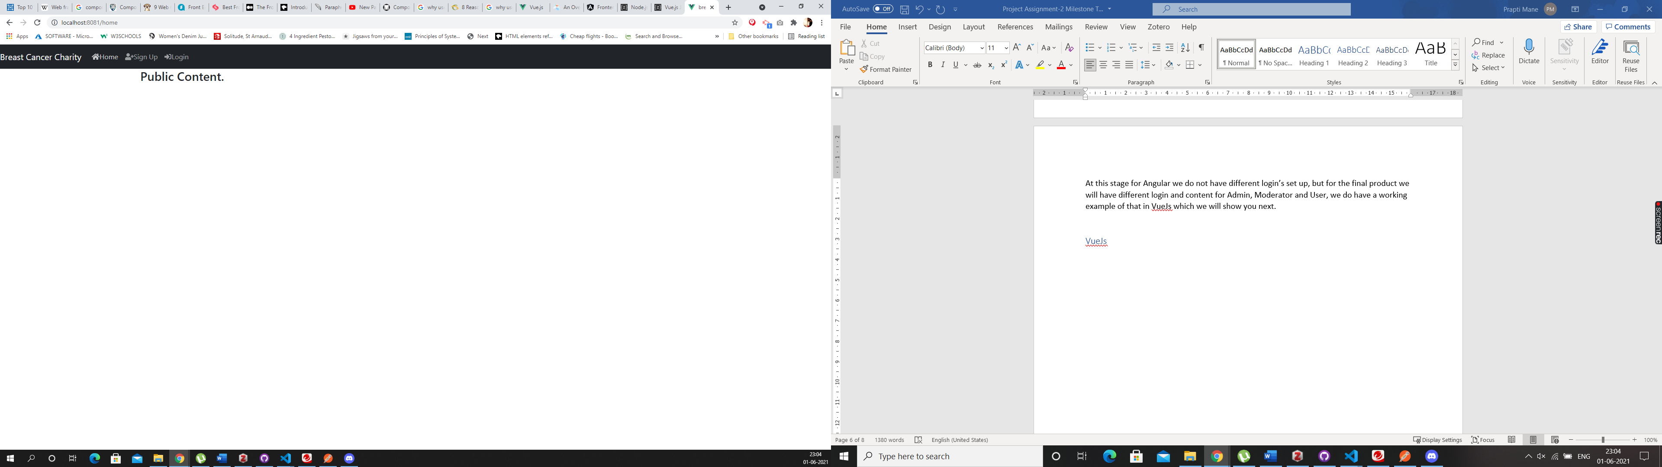

Click on the Sign Up in the navigation bar and it will direct you to this page - <http://localhost:8081/register>

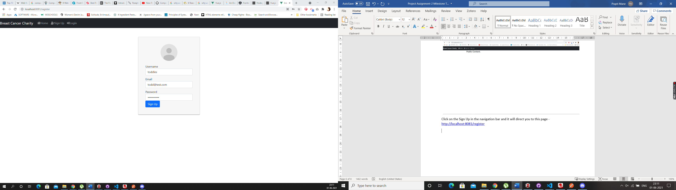

Enter you details as shown in the above picture and then press the “Sign Up” button. Once you register you will be shown the below screen

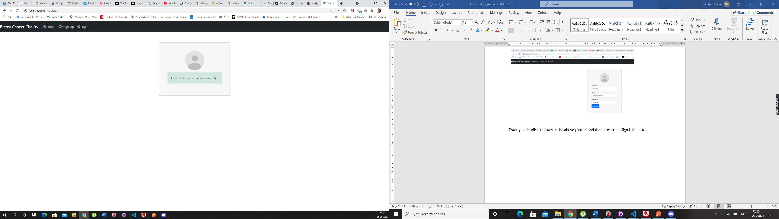

Then go to the Navigation bar and click on the Login button, you will be directed to the below screen : <http://localhost:8081/login>

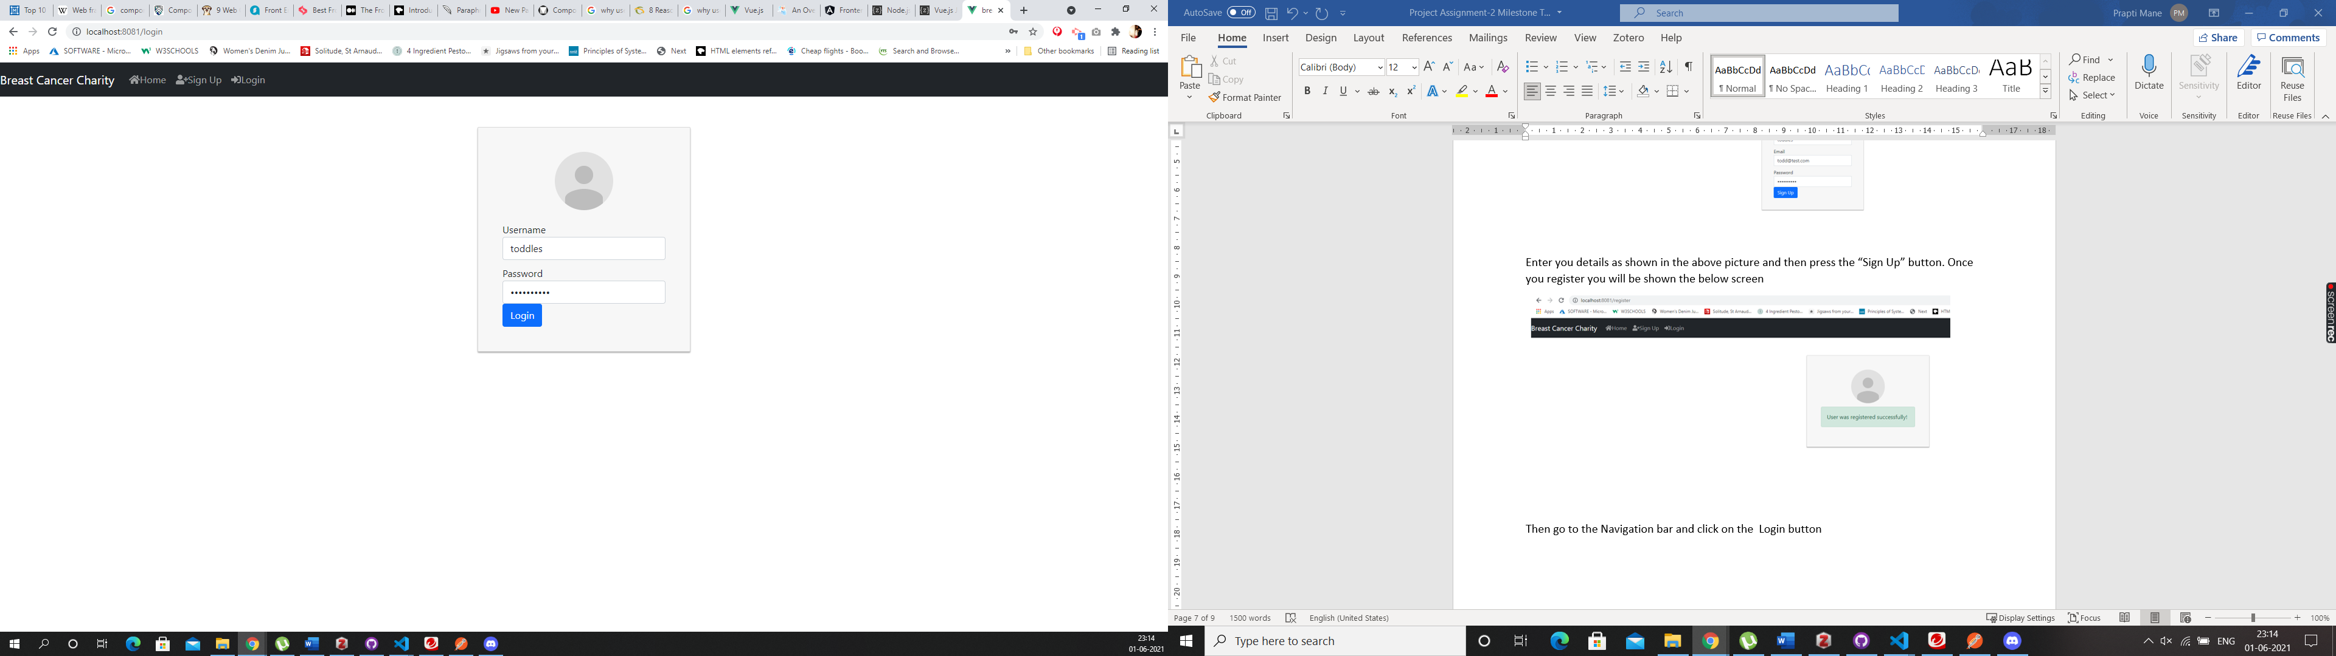

Enter your details and click on the “Login” button, which will take you to the below screen, which is the Profile screen - <http://localhost:8081/profile>

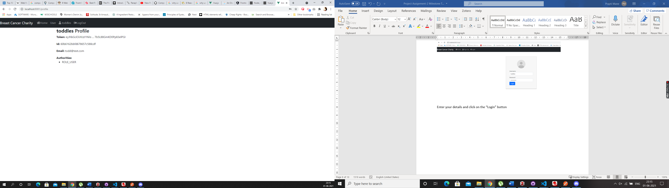

As you can see in the above image, the profile that we have created is for that of a User, so when a regular user goes onto the website and register themselves, they only have access to the content that is created just for the user’s. If you click on “User” in the navigation bar it will direct, you to the below screen. <http://localhost:8081/user>

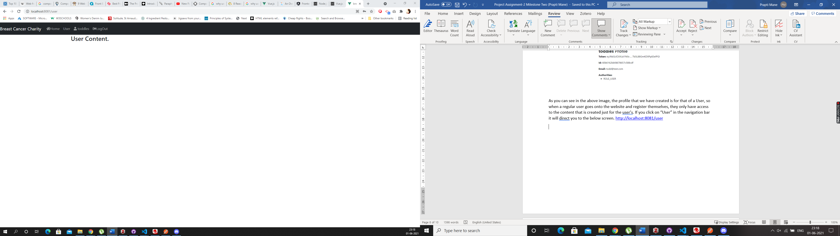

As you can clearly see that the content that the content on this page is specifically designed for the users.

If you want to create a Moderator or Admin account, it can be done through the backend. I have created an Admin account using Postman for this website. I am going to login into that account and show you the difference between the two. As you can see there is no way a user can register as an Administrator unless they do it through the backend, which is a good option as you do not want everyone to have access to the admin account.

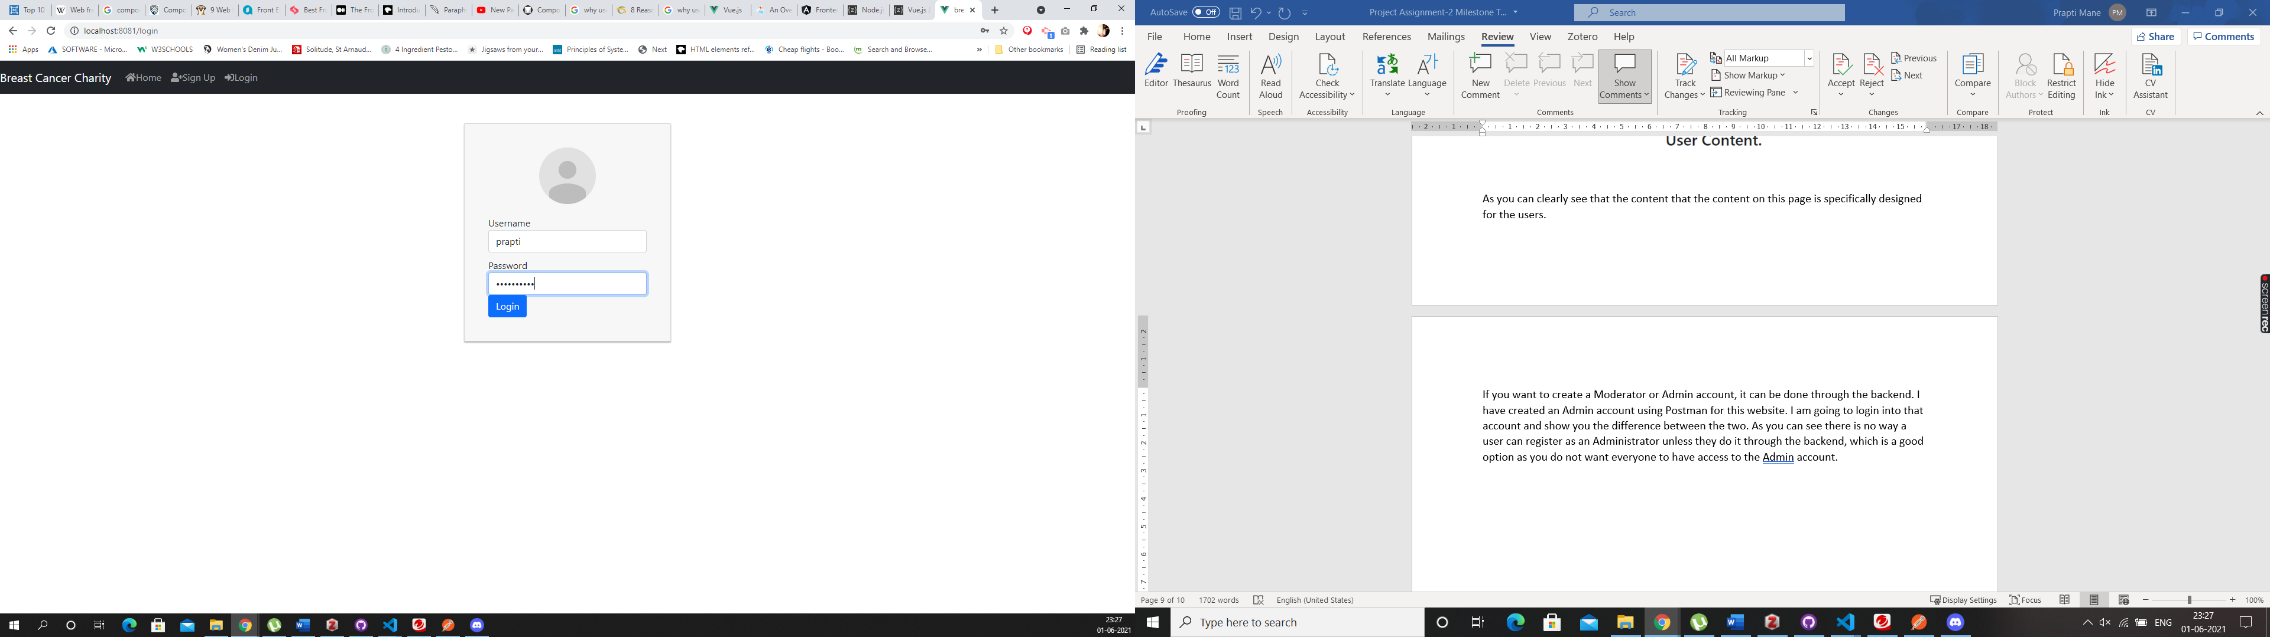

In the above screen as you can see I am going to login as “Prapti” since I have already created an Admin account for me. Once you click the “login” button you will be directed to the below screen

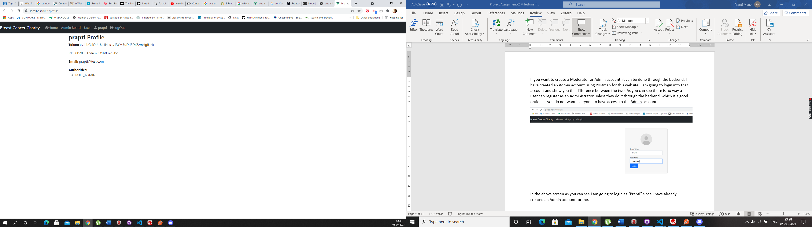

As you can see once logged in as an Administrator, I have access to the admin board, which you cannot see from the user account, but I also have access to the “user account” content. As an admin I can access anything on the website but a regular has access to limited content on the website, they will only see what we show them.

We also have a third type of account on the website which is a moderator account. I have logged in using “kayla” account who is the moderator for the website, but also have access to the user account. Below is a screenshot of the dashboard for a moderator account.

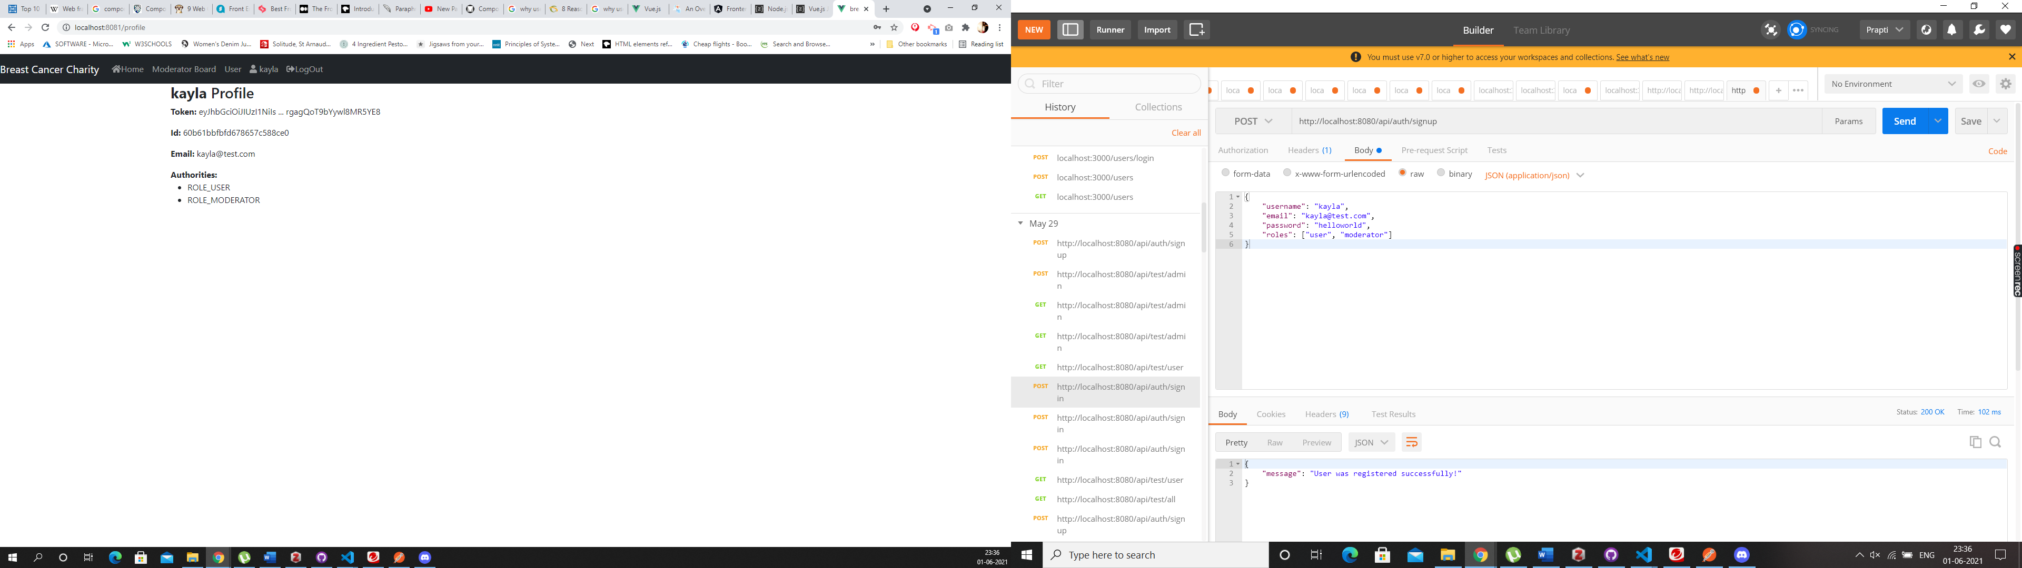

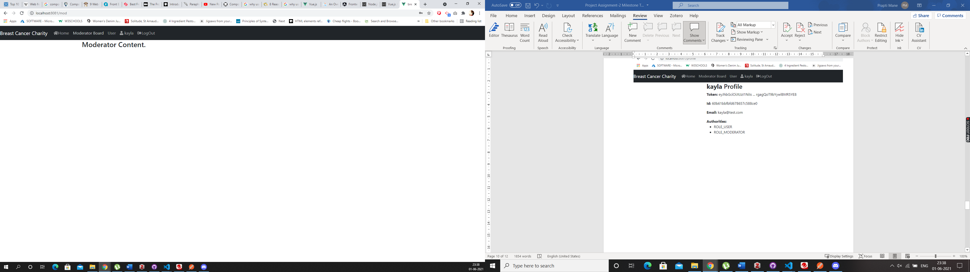

As you can see Kayla’s account has access to the Moderator content and the user content but not the Admin content. These roles can be changed using the backend/ postman.

## Code Snippets

VueJs – User Model Angular – User Model

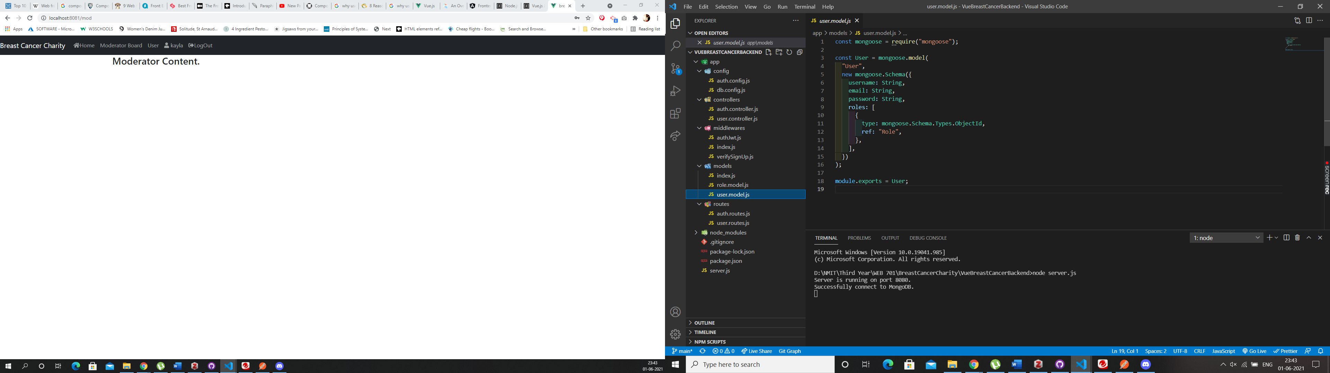 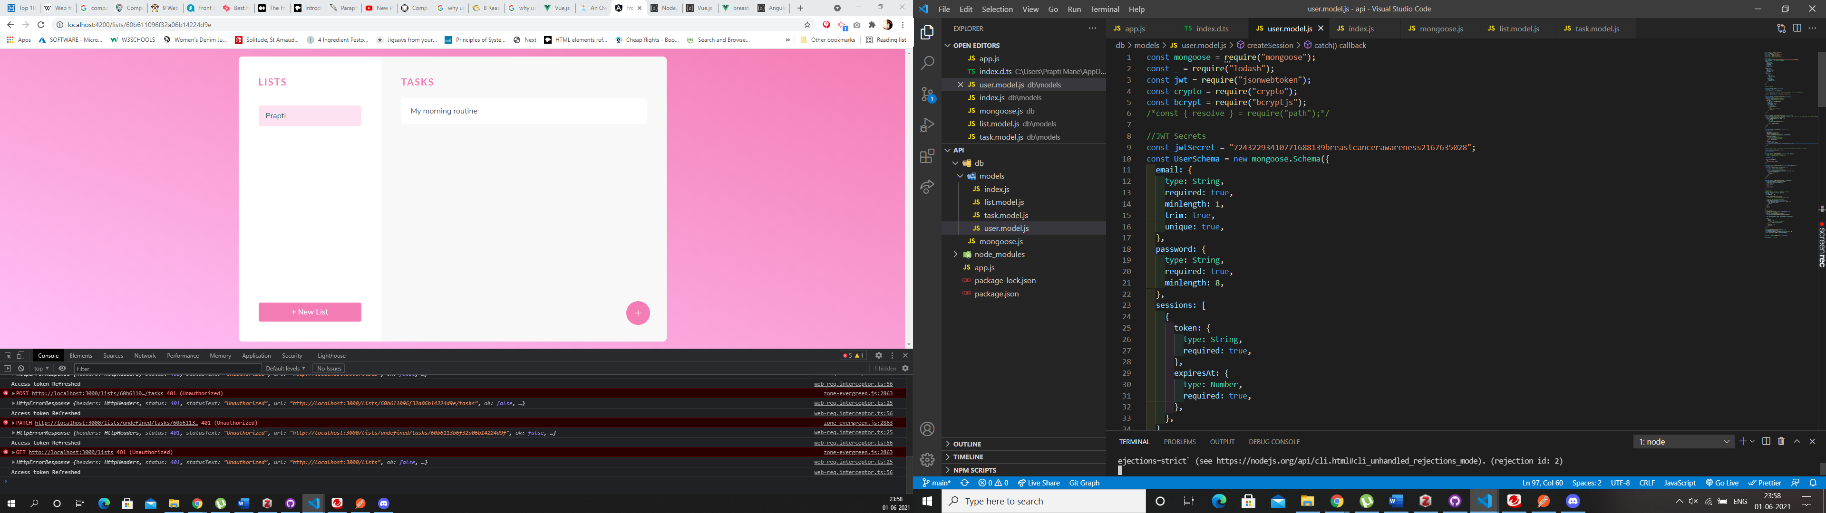

The code in VueJs is pretty straight forward, whereas in Angular in User Model most of the methods are especially including the refreshing of JWT tokens it is all set up in the User Model making the code far more complicated to read. Although this can be sorted if we create a separate model in angular which will deal with the Access tokens this issue can be sorted. The helper methods everything is in the UserModel in angular at this stage. This code could’ve been written better by segragating it.

The code in VueJs is simple and not at all complicated, it shows exactly how the UserModel is using Mongoose and what values are needed for a user. This is how the data will be collected in MongoDb database. It is easier to understand that the User object will have a roles array that contains ids in roles collection as a reference.

## Comparing Frameworks – Registration and Login

When it came to coding the registration and the sign-up part of the website, I did find the VueJs framework to be easier than Angular. Although both the websites do have similar patterns, certain parts in Angular are much more complicated than VueJs, as mentioned online VueJs initially was inspired by Angular, and any complicated parts of Angular were made simpler in VueJs hence the code also looks similar but is much more complicated in Angular. The security side of things when it comes to login and registration felt the same, although applying JWT felt a bit more complicated in Angular as it did in view, and as you can see in View it was easier to accomplish the exact login functionality as per the requirement whereas in Angular so far we have only been able to login as a regular user with no defined roles. One of the major drawbacks I found in Angular is that Typescript is mandatory. Vue is more flexible when it comes to that.

Angular deals with Modules whereas Vue is about Components. Angular is all about MVC, which we have worked with in react in the past, so understanding it was slightly easier.

# Members Use the Website to register their products.

## Angular

Once logged into the website a user can create a list of tasks, each list will consist of it’s own task, this can be used by the users to keep track of their health and their routine checkups. Below is a screenshot of what the list and tasks look like on the website.

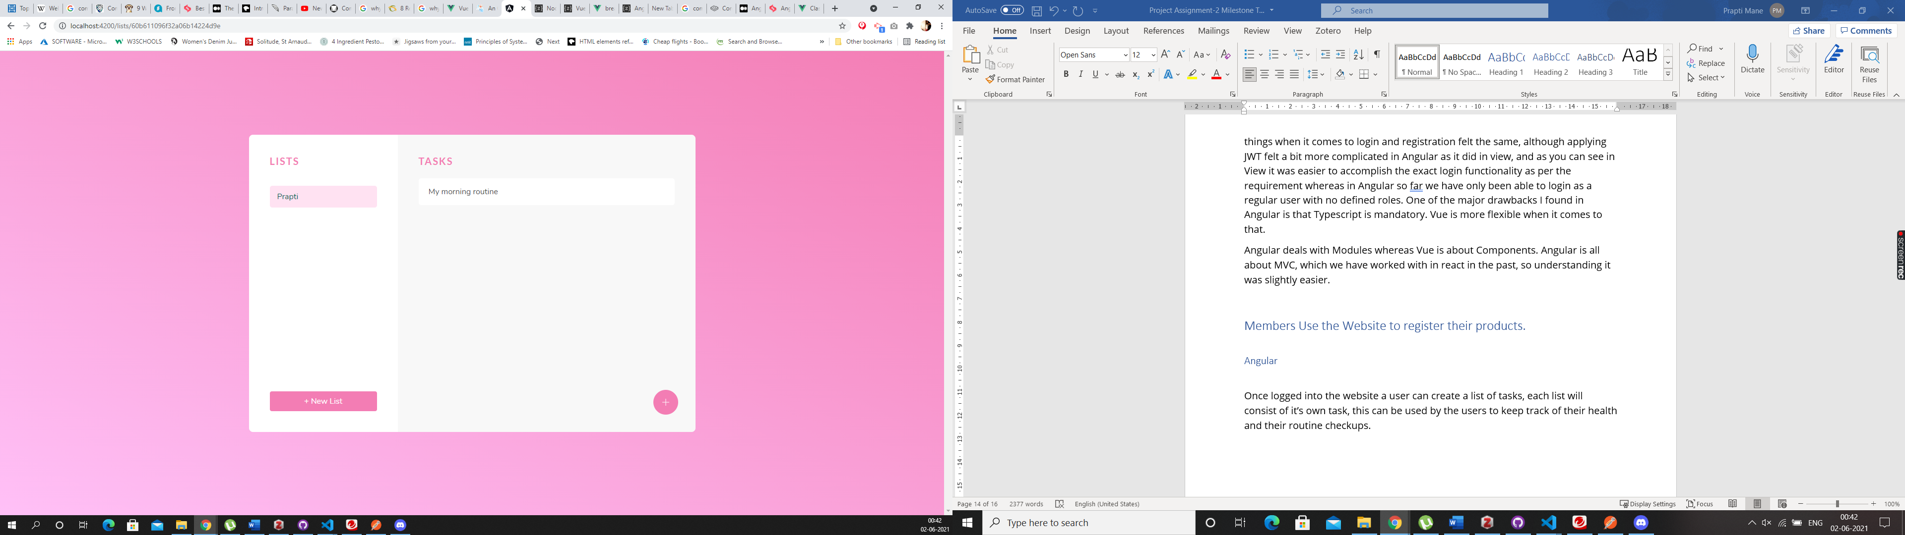

The lists can only be seen if the user is logged in. Since I am logged in as Prapti, the tasks you see in the list are part of my account. To add a new list you need to click on the “new list” button and you can create a new list, and to add a task into that list just click on the list and then click on the “+” button on the right side corner of the page, this will allow the user to create a task for that particular list. Let me add few more tasks to my list and show you what it will look like.

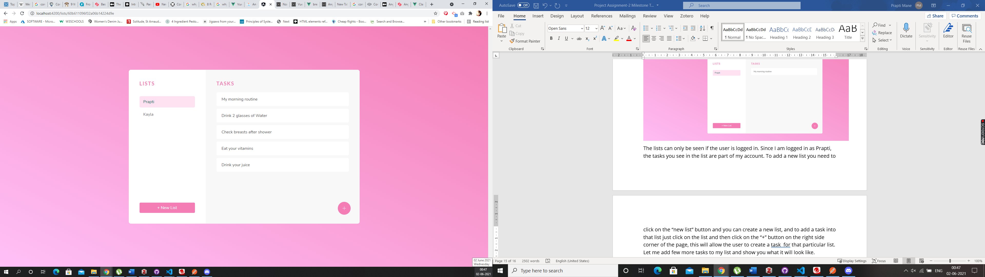

I have added some more tasks in the list called Prapti, I have also added another list called “Kayla” this has no tasks in it, let me show you a screenshot of what an empty list looks like.

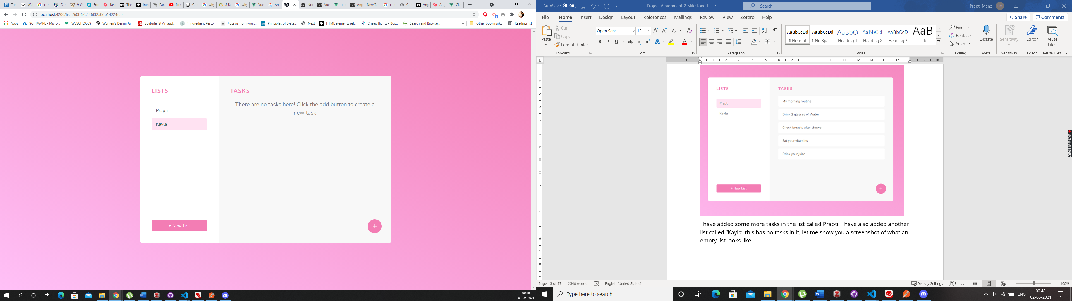

## VueJs

We can create the same functionality in Vue, by creating a list model and task model in the backend. And then using the routes in the server.js file direct to these models. And we can make lists based on the roles and the users logged in. And we can populate the content of the website using the App.vue. We would have to create List.vue file and then add it to the navigation and give it the path using the router.js. We would have to load it in the mongoose models aswell so the lists and the tasks can be stored in the database.

## Code Snippet

Below is a screenshot of what the code looks like in Angular for the List Model

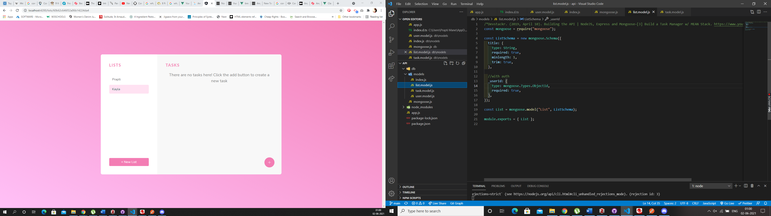

It is very similar to the User Model only less complicated. This handles the authentication of list based on the userId. You must export the task and list modules from the models into the index.js.

App.js is where we create our list, and find a list created by a particular user, create a task, based on the user logged in and who created a list and the task in that particular list, all of that is handles in the App.js please find below some screenshot of what App.js looks like on the website. The code is commented for your better understanding.

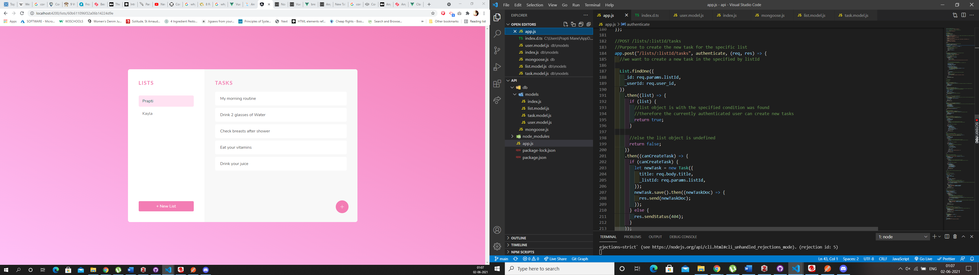

If you want to see the code and what it is doing in the front end just inspect the page open the console, you will see that the Token is getting refreshed and the user is not getting kicked out, they’re still logged in and can continue with their work on the website.

## Comparison

As both the websites are not fully doing what the requirement is, Angular comes very close to show the functionality that is required, same results can be achieved using Vue.js. As explained on the top we would have the create the list and task models and use them accordingly on the website. The steps for this process are mentioned above, creating a list and task was not a hard task in Angular as it was explained well in the tutorial how to do it, but I reckon if we use the same steps in Vue and follow the similar concept of login, and just add it to the List and Task based on userId this can be easily achieved. For this particular functionality I found both Angular and Vue pretty similar.

# Interactive Engaging Elements

## Angular

We have the lists and the tasks on the website which are some of the interactive elements on the website. A user can create a list and a task inside the list once logged in. The page is styled using CSS. There will also be a booking system on the website which will help a logged in user to redeem a coupon and book a free appointment for checkup. The coupon will be displayed on the website. The interactive element on the website so far is the sign up, login, creating a list and creating a task. In the future we would also allow a user to delete a list or update a list using the front end. This functionality is available using Postman for now, but soon we will have it on the front end aswell. So, the user will never have to use the backend for anything. Anyway in a website we should never give a user access to the backend unless they’re the Admin for the website.



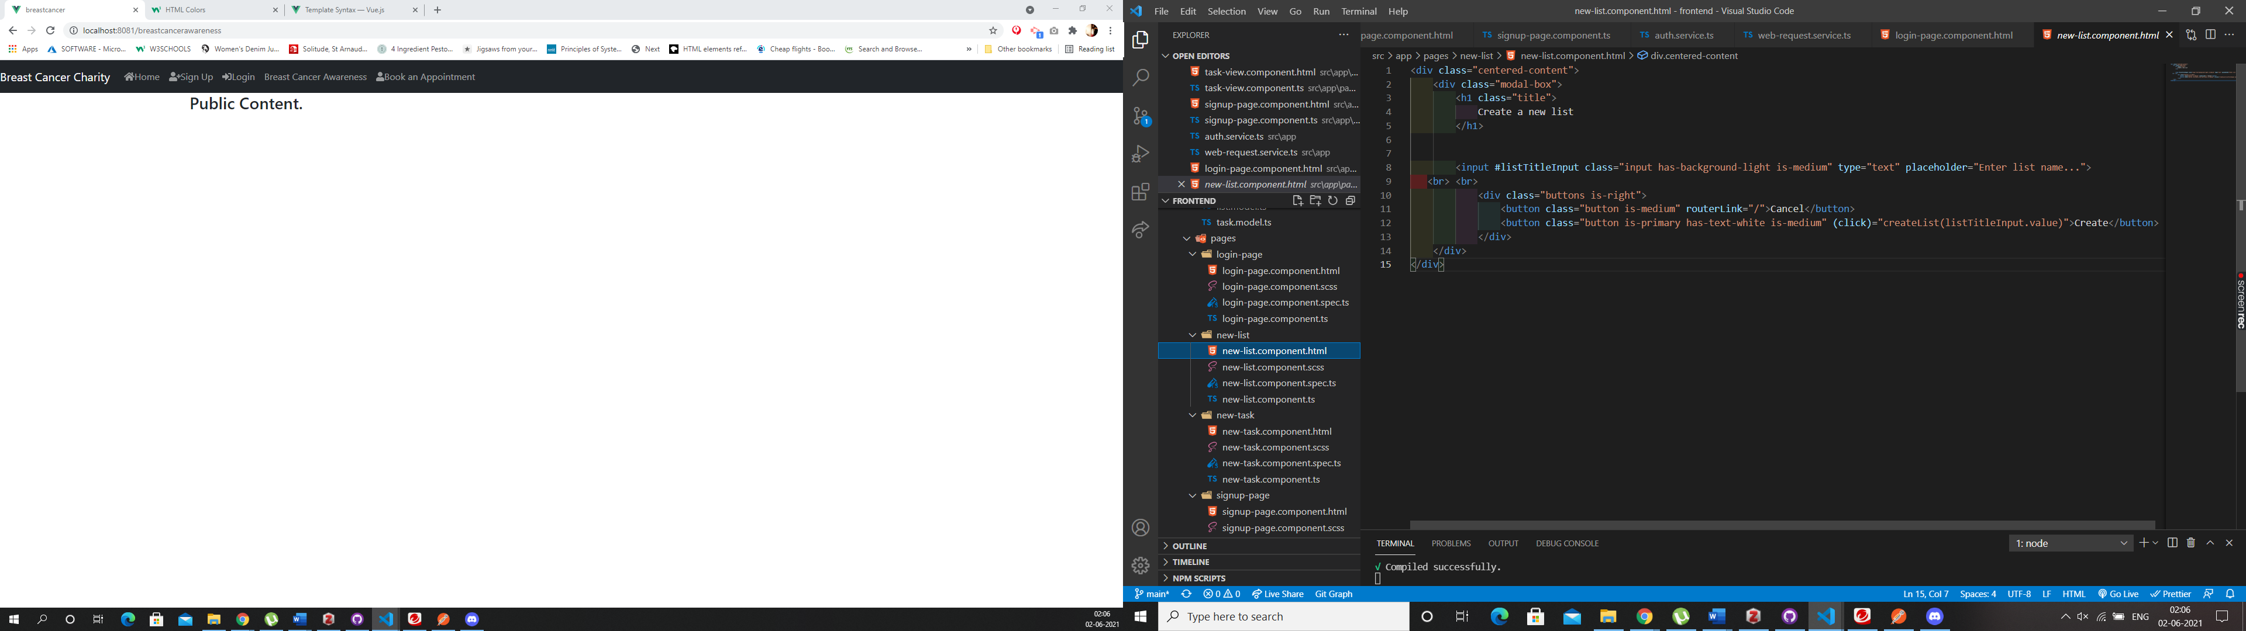

## VueJS

The interactive elements in our view app are the sign up and the login, I have also set up two more pages which is the Breast Cancer Awareness and the Book an Appointment, which you can see in the Navigation Bar, but as of now these two new pages have no content in it. The Breast Cancer Awareness page will contain public content as it is the page that should be available for all types of account holders. The Book and Appointment page will be accessible only to the users who are logged in.

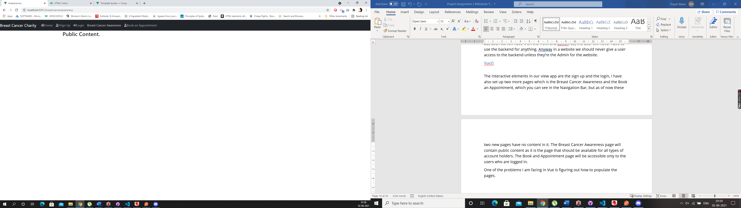

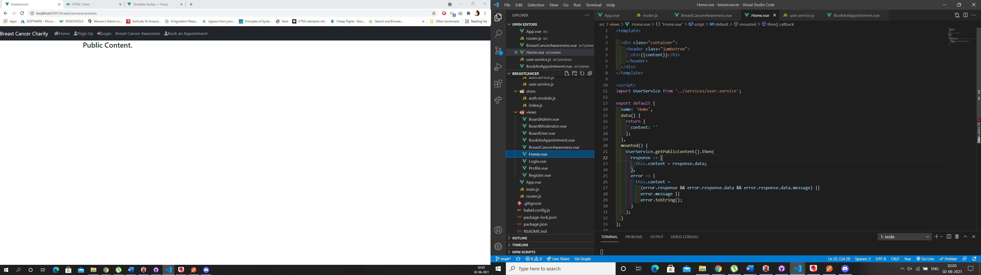

One of the problems I am facing in Vue is figuring out how to populate the pages.

## Comparison

In angular populating pages is a very straight forward concept, you have an html page for your components, in which you write your html code with classes, and you style those classes in your CSS file, you can have one global css file for the entire website, so you do not have to search every time and all the styling is available in one place. But in Vue, that is not the case, there are no HTML pages and when I write the HTML code in the vue files, it gives me an error. This is something I still need to figure out how to do, this can be easily figured out and should not be a problem for the website. So far in the Vue code we haven’t used any CSS, hence the app is not at all appealing to the eyes. But this can be controlled by creating a CSS global file and turning all components into classes, similar to what is done in Angular. For the front end I did enjoy working on Angular, as their documentation was precise and well explained. Vue also has a good documentation, but it is more focused on the backend then it is on the front end and I didn’t find it as helpful as the angular one.

# Store and Retrieve Data from Server-Side Database

## Angular

We have created our database using MongoDb, to make sure that your application is connected to the Database and working fine, first you need to install Mongoose in Angular. The reason we do this as it helps to create a more secure application. MongoDb stores data in documents that can be retrieved as JSON objects. You have to make sure you have Express API set up for your project and then install mongoDB.

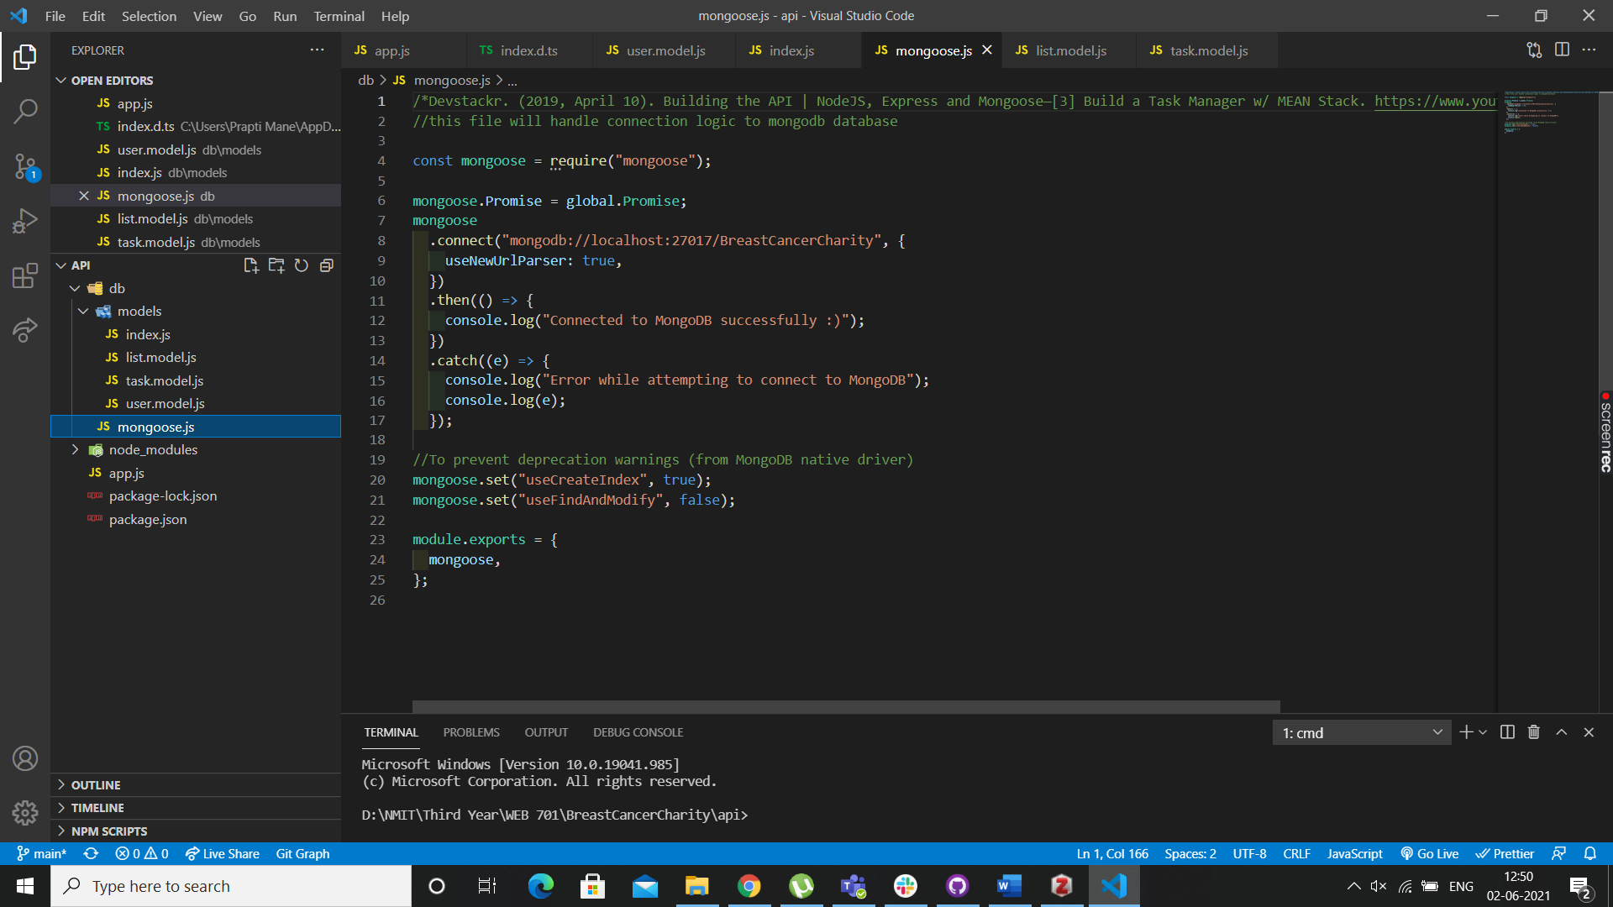

This is the code we have in our mongoose.js file, this code handles the connection logic to mongoDb. If you have everything set up correctly you will see the message “connected to MongoDb successfully” in the terminal, the command we use to start our backend is “nodemon app.js”. Please see the screenshot below to see what it looks like when in the terminal. We have to make sure we have node installed in the application. As you can see we’re running it on a different port as compared to VueJS we’re running it on port 3000.

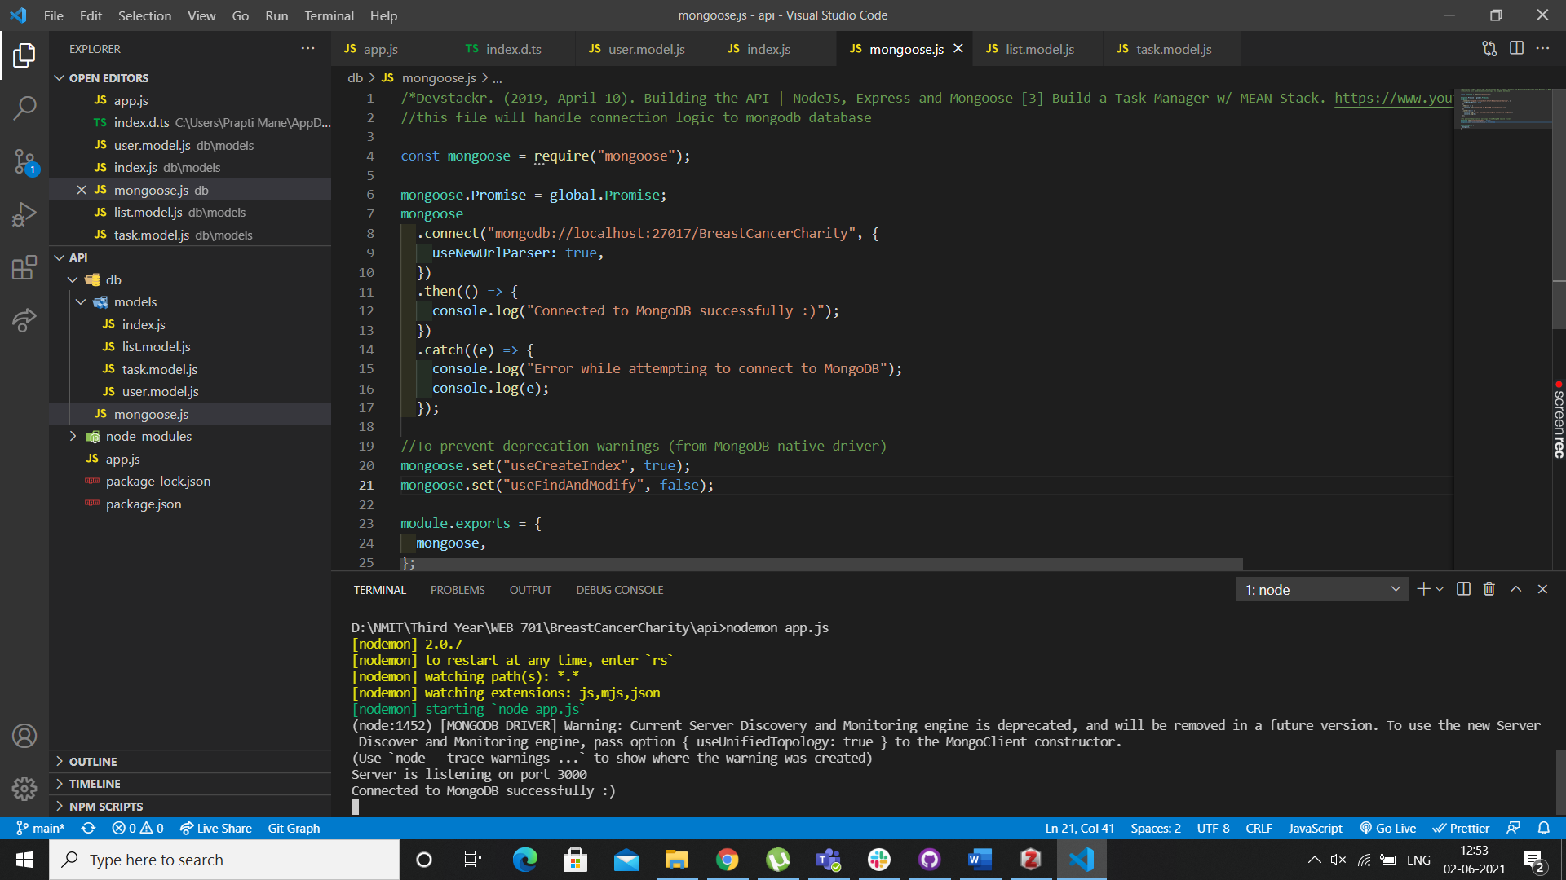

The above screen shows how we have successfully connected to the Database before you run the Front end of the application always make sure your API is running first. We are using our database to store the users and the lists and the tasks in the lists.

JSON Web Tokens, or JWTs, are a popular replacement for cookies. For API call authentications, they are a mechanism to keep user session data in Local Storage. Because of the many supporting libraries for browser and server-side handling of JWTs, this has become more popular than keeping cookies in Local Storage. The data is called using the Http Request using the routes and then that gets sent to the JWT Authentication middleware’s and controllers and then the MongoDb database, then the MongoDb gives a response back, and it is then sent to controllers and using Express it the response is sent to Http. The process on how the database works is the same for angular and VueJs.

Below are the screenshots of the frontend showing that the data is getting stored in the database and being called when required, both for the users aswell as the lists.

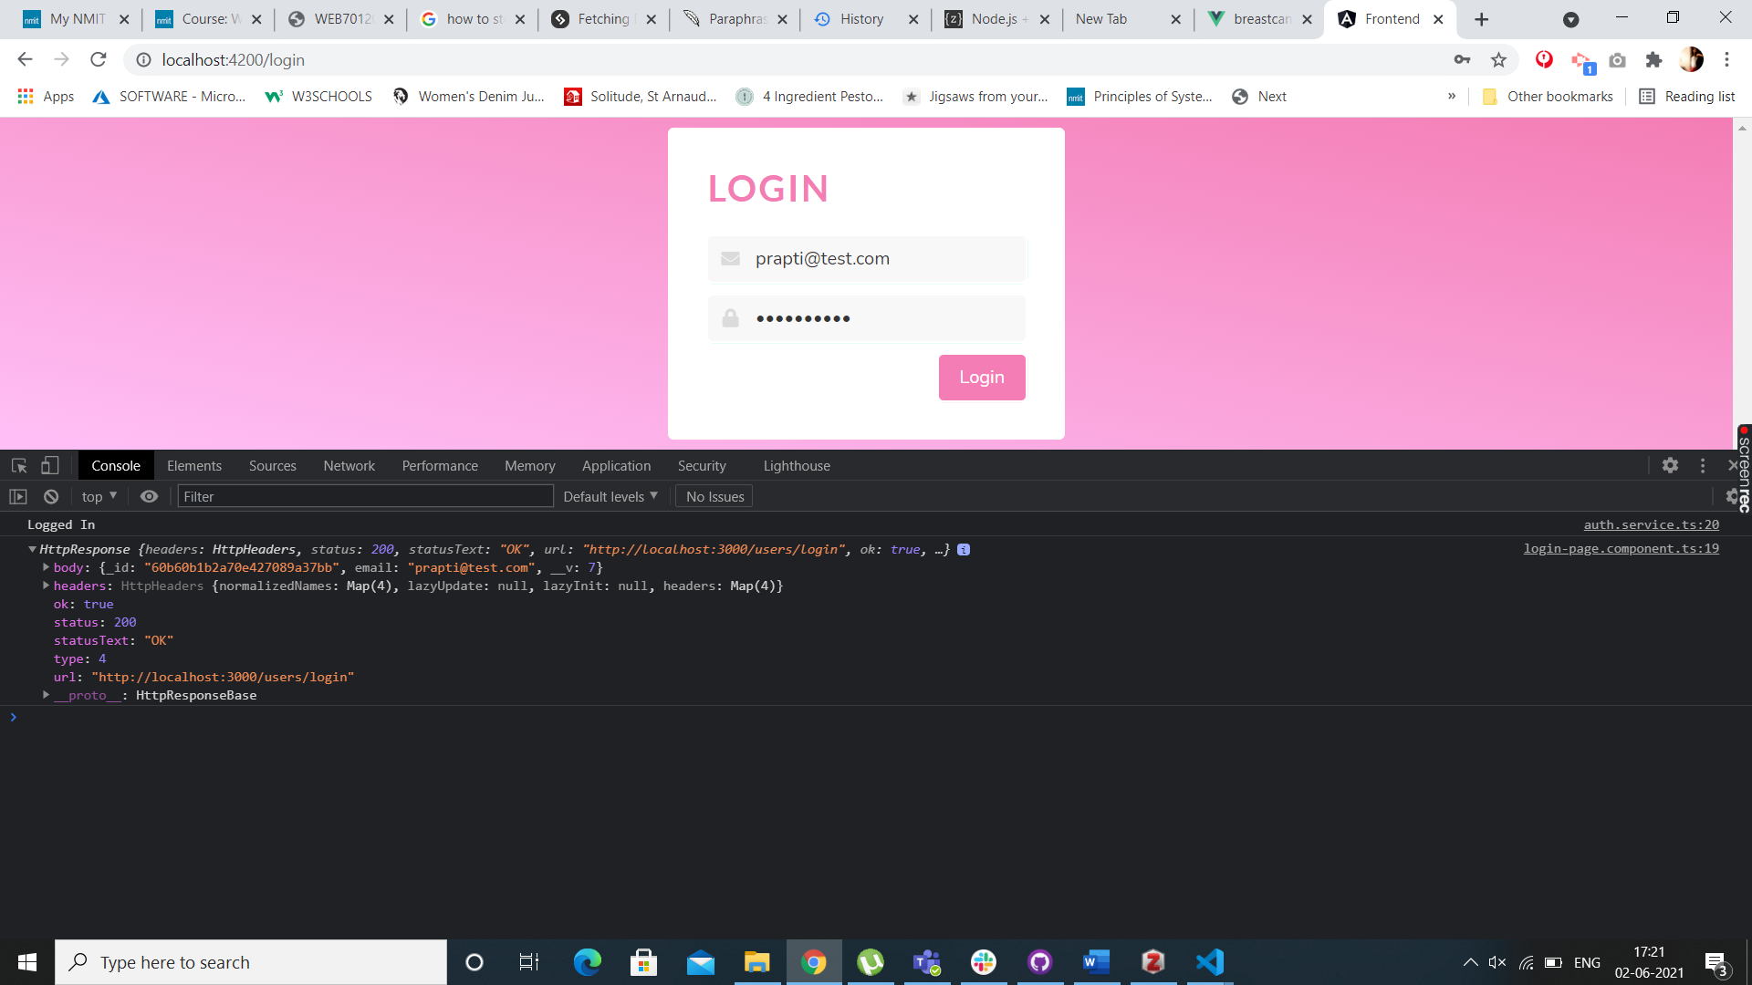

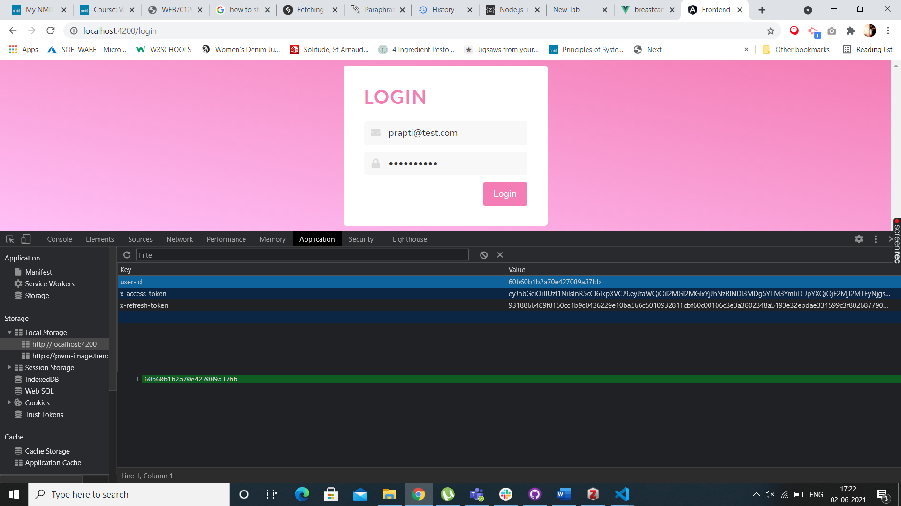

## VueJS

In VueJs we first initialize the node.js app with a package json file. Then we must install the modules which are, express, body-parser, mongoose, jsonwebtoken and bcrypt.js. Once all the modules and packages are correctly installed you can see it in the package json file under dependencies below is a screenshot of what the parameters set for database looks like

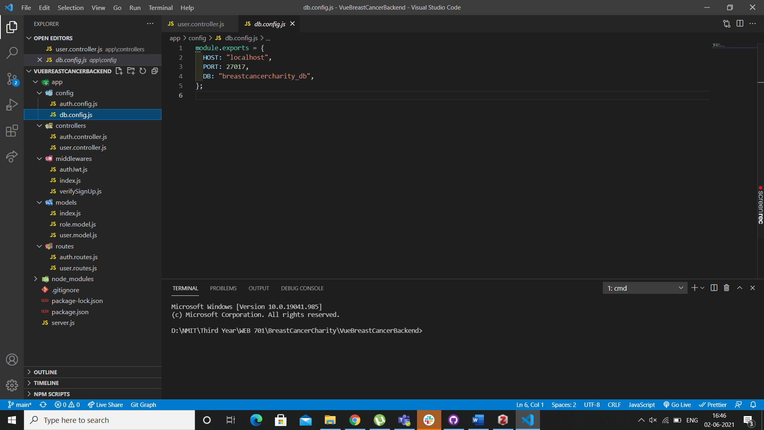

Then we create Models for User and Roles which we will be storing in the database, hence these can also be called the Mongoose models.

Below screenshot will show you how to initialize Mongoose

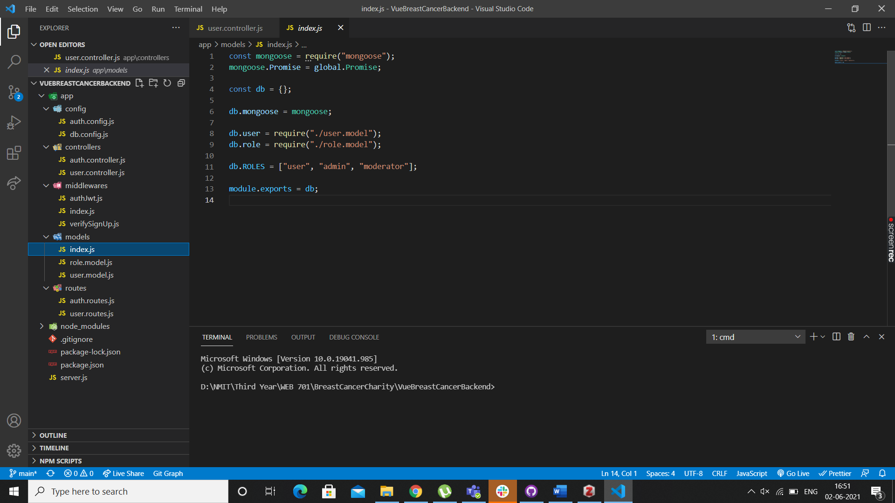

Below code will show you how we create a connection between Mongoose and MongoDb database.

This code looks very similar or almost identical to what we have in Angular, that’s because certain things which aren’t complicated have been kept the same in VueJs

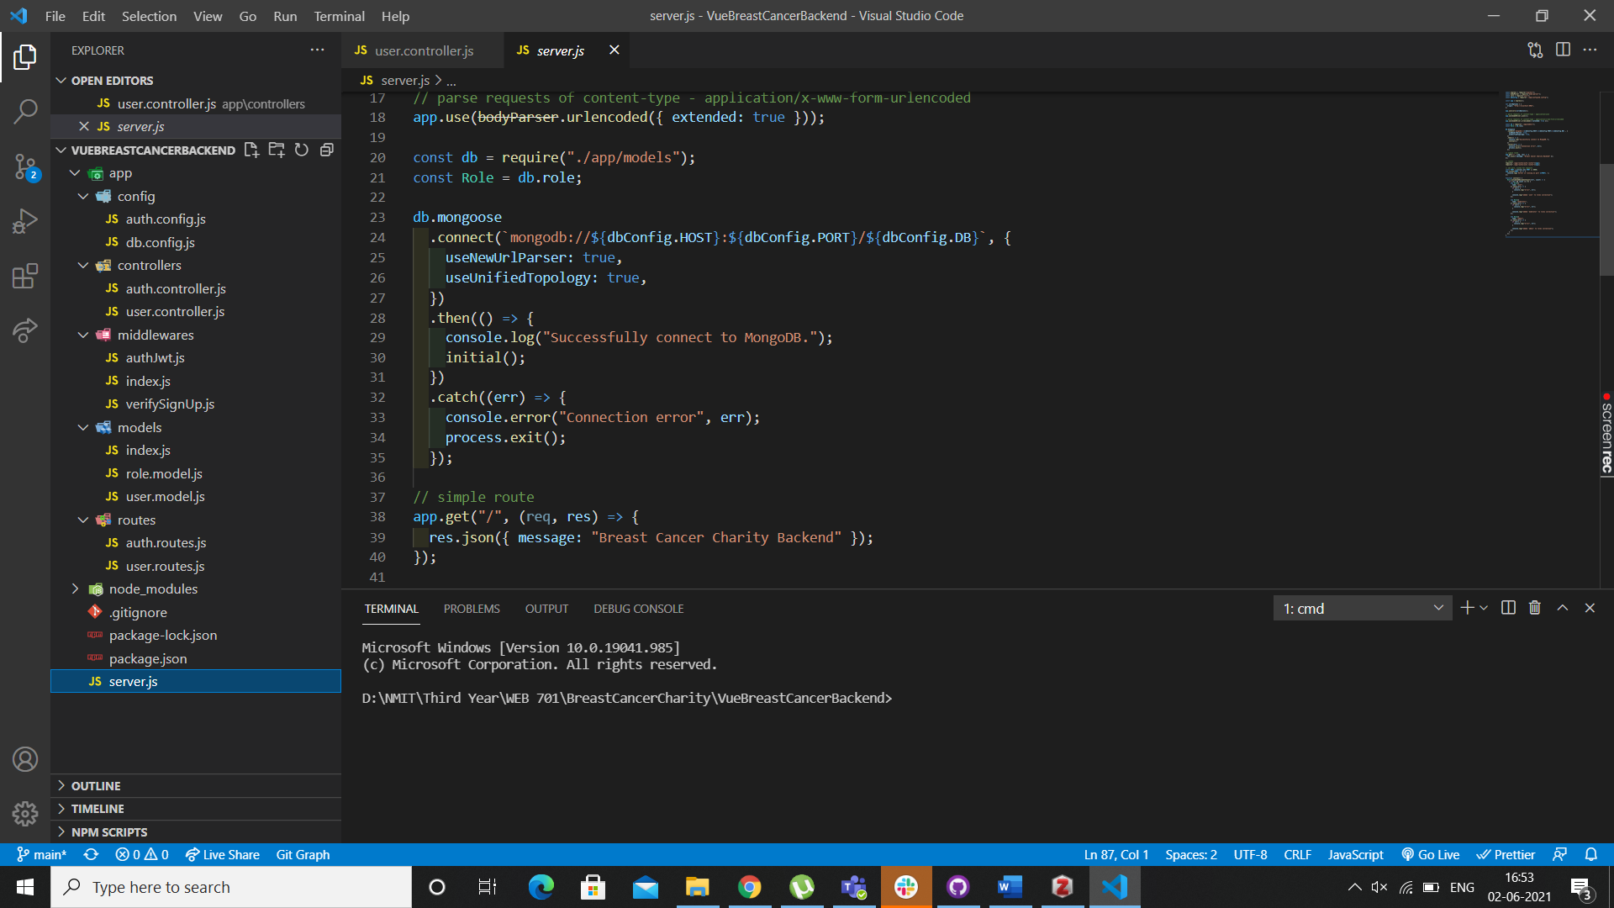

Now if I run the above code using the command “node server.js” this helps the application to run on the port which was mentioned before which asks the application to run it on the 8080 port, lets run this and see the screenshot of what the terminal looks like.

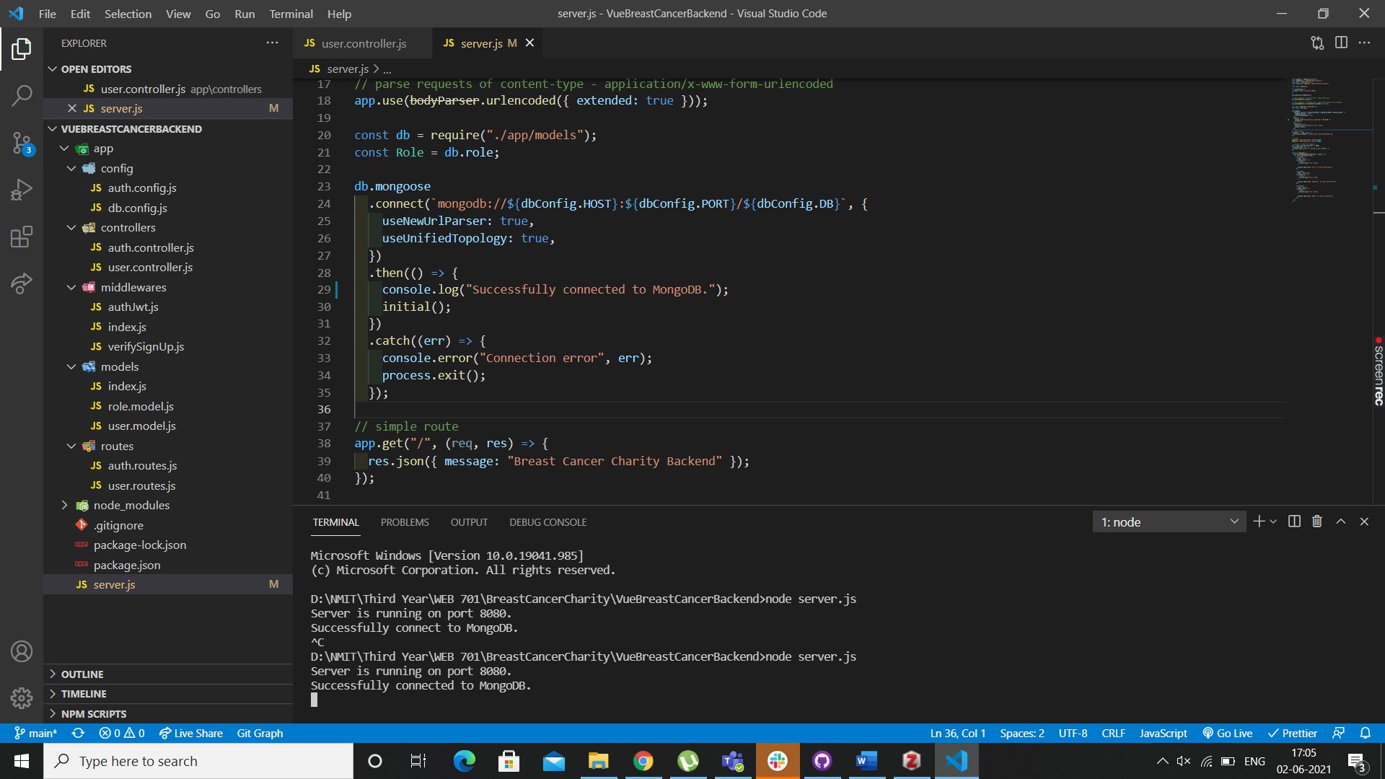

As you can see the mongoDb is running successfully which means the API is connected to the database successfully using Mongoose. If we decide to add more roles or users the database will keep on adding it, it is best to use Mongoose for a functionality like this but if you intend on keeping sensitive information stored on the database, I recommend we use MySql as it is even more secure.

Below is a screenshot showing that the user is stored in the database, if you inspect the page and go to Application you should be able to see the local storage, and that the user is stored in the database, when they first registered.

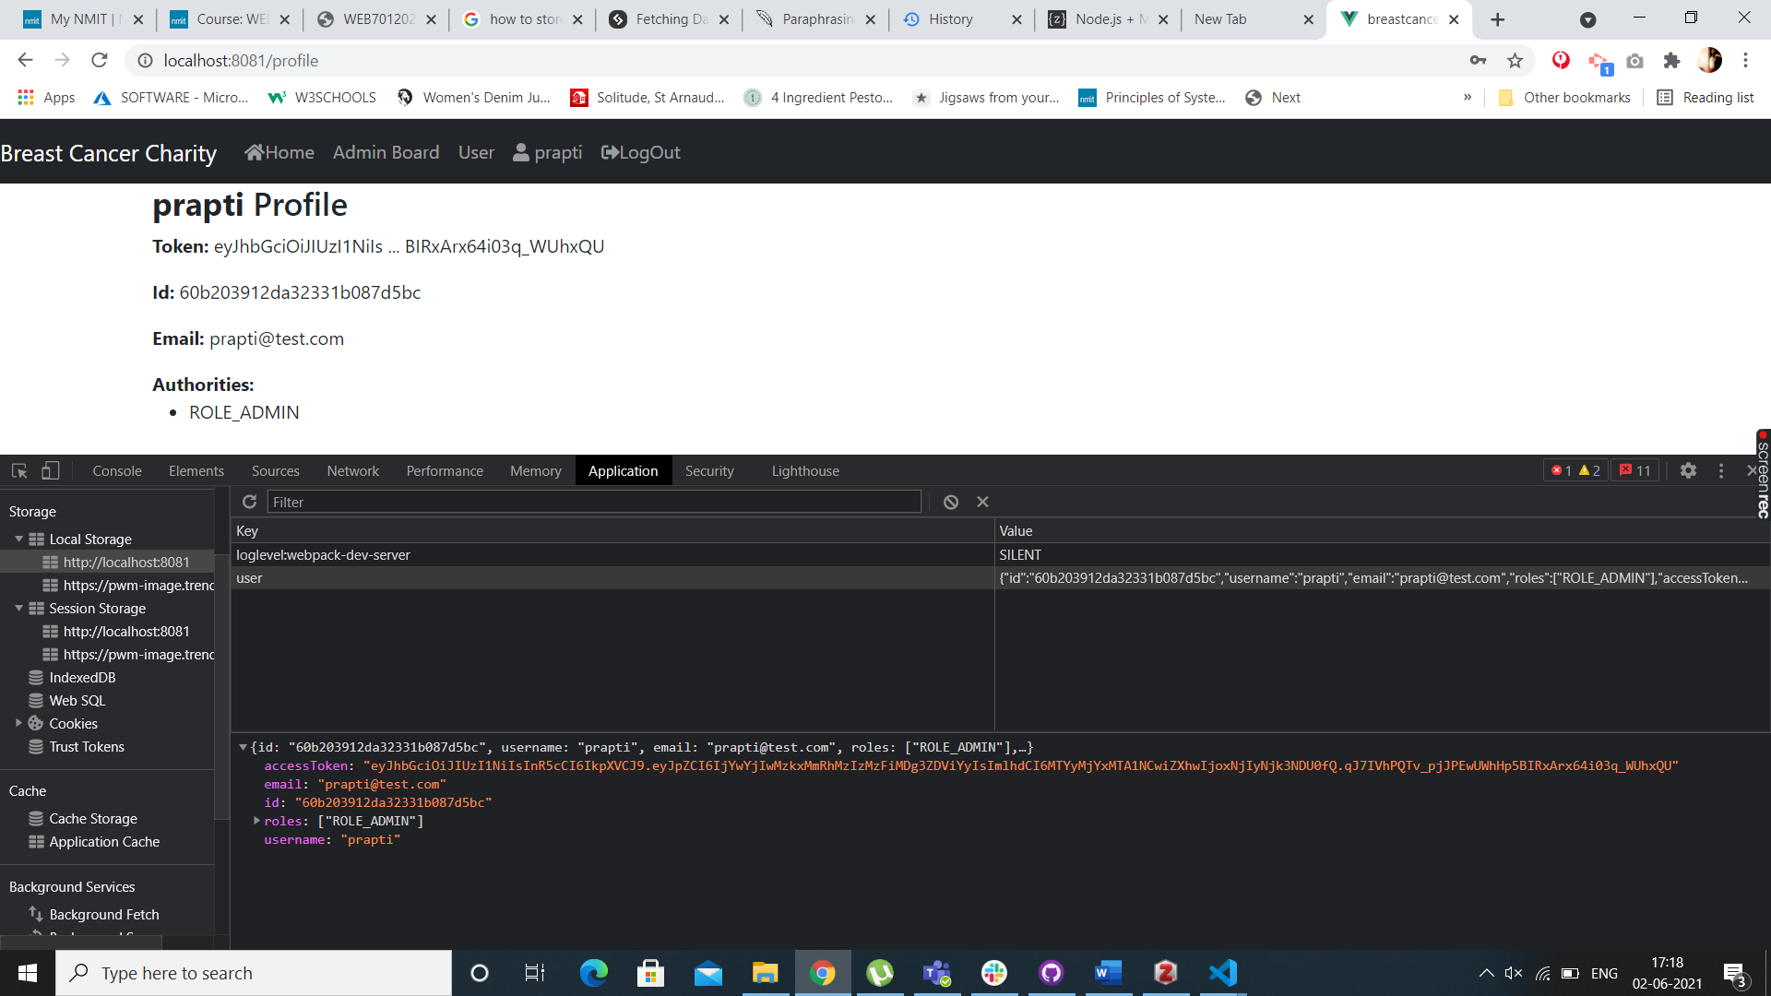

## Comparisons

The API for connecting to database and calling data and sending a response to http works in the same manner in both these frameworks. They’re very similar and most parts of the code to achieve the same results are almost identical too. Yes I still haven’t been able to figure out how does making a list works in VueJS but I reckon the process is the same as what it is in Angular. In both the frameworks request, respond and next is used.

# Recommendation of a Framework

After working on both the frameworks and trying to achieve the same results, I have realized that both the frameworks are very similar and yet very different. I have worked on both the Client and Server side and have come to realize the framework that we are recommending for this website is the Angular Framework. As we have achieved most of the backend functionalities and now need to focus on the front-end of the website, I reckon it will be easier to work in Angular. We are recommending the MEAN stack approach for this website.

M – MongoDB

E – Express (back-end middleware)

A – Angular (front-end framework)

N – Node.js (run time environment)

We already have these modules set up for our project.

Some of the reasons why we prefer Angular as a framework are :-

Angular is build in the MVC architecture which is the Model – View – Controller architecture. The framework has Model and View synchronized so if the model changes so does the view. Because it has two-way data binding the coding time for developers has significantly dropped. This will result us in not writing unwanted code, which will help us save time and money.

Developers may apply special behaviors to the Document Object Model (DOM) via directives, allowing them to generate dynamic and rich content with HTML.

Dependencies describe how various pieces of code interact with one another and how changes in one component affect the others. Dependencies are usually defined explicitly in the components themselves. As a result, every change in dependency necessitates a change in components. You might utilize injectors in AngularJS to define dependencies as external elements, which would decouple components from their dependencies. Components become more reusable, manageable, and testable thanks to dependency injection.

Angular has a huge community since it has been around longer than VueJs, because it is widely popular there is more documentation available for Angular also there is enough training material to solve any problems which arise during the development time of the website. Personally, working on both the frameworks I found Angular to be straightforward. Some bits were complicated and hard to understand but once you get the hang of the framework, it does become slightly intuitive.

Angular components are small user interface elements, similar to sections of an application. In Angular, there is a tight hierarchy of components, even though each component is contained with its own functionality. The components are well encapsulated for reusability. Encapsulation is also helpful for new developers to understand the code faster and better. Unit testing and maintenance of the code is much easier in Angular and efficient too. Dependency injection also helps with high performance of the website. (altexsoft)

# Bibliography

What is a Web Framework? (2017, July 28). *GoodFirms Glossary - GoodFirms*. <https://www.goodfirms.co/glossary/web-framework/>

*What is a web framework? | CodingNomads*. (n.d.). Retrieved May 30, 2021, from <https://codingnomads.co/blog/what-is-a-web-framework/>

*Why do we use Web Frameworks?* (2017, June 19). LispCast. <https://lispcast.com/why-web-frameworks/>

*How useful are web application frameworks? & How do I know which framework would suit me?* (2014, September 23). Cuelogic Technologies Pvt. Ltd. <https://www.cuelogic.com/blog/how-useful-are-web-application-frameworks-how-do-i-know-which-framework-would-suit-me>

Web framework. (2021). In *Wikipedia*. <https://en.wikipedia.org/w/index.php?title=Web_framework&oldid=1022782175>

Web service. (2021). In *Wikipedia*. <https://en.wikipedia.org/w/index.php?title=Web_service&oldid=1021433007>

*8 Proven Reasons You Need Angular for Your Next Development Project*. (n.d.). Grazitti Interactive. Retrieved June 1, 2021, from <https://www.grazitti.com/blog/8-proven-reasons-you-need-angular-for-your-next-development-project>

The Good and the Bad of Vue.js Framework Programming. (n.d.). *AltexSoft*. Retrieved June 1, 2021, from <https://www.altexsoft.com/blog/engineering/pros-and-cons-of-vue-js/>

*How to Connect Angular and MongoDB to Build a Secure App*. (n.d.). Okta Developer. Retrieved June 2, 2021, from <https://developer.okta.com/blog/2019/09/11/angular-mongodb>

*Managing Local Storage in Angular*. (n.d.). Briebug Blog. Retrieved June 2, 2021, from <https://blog.briebug.com/blog/managing-local-storage-in-angular>

The Good and the Bad of Angular Development. (n.d.). *AltexSoft*. Retrieved June 2, 2021, from <https://www.altexsoft.com/blog/engineering/the-good-and-the-bad-of-angular-development/>